Paper 2 Figures and Tables

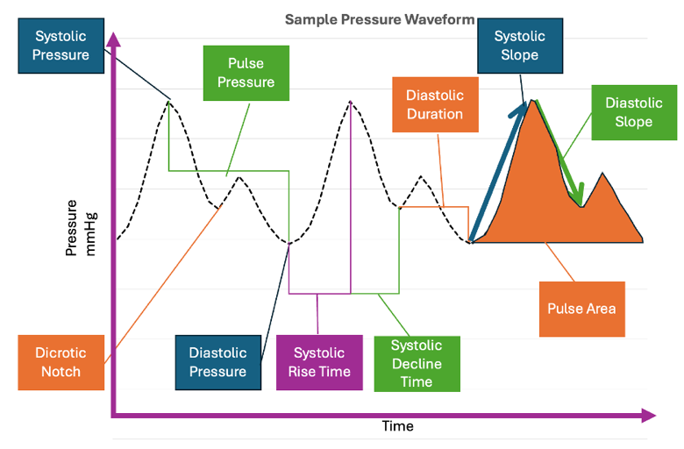
Figure 1. Representative arterial blood pressure waveform illustrating some key hemodynamic features. This sample waveform highlights systolic blood pressure (SBP), defined as the maximum peak pressure, and diastolic blood pressure (DBP), defined as the minimum trough pressure. The inflection point blood pressure (IFBP), corresponding to the dicrotic notch, marks the transition between systole and diastole. Pulse pressure (PP) is defined as the difference between SBP and DBP. Temporal characteristics include systolic rise time (t_sys_rise), representing the interval from waveform onset to peak systole; systolic decline time (t_sys_dec), representing the interval from peak systole to the inflection point; and diastolic duration (t_dia), representing the interval from the inflection point to the end of the pulse. Morphological features include the systolic slope (slope_sys), indicating the rate of pressure increase during systole, and the diastolic slope (slope_dia), indicating the rate of pressure decay during diastole. The pulse area (PA) represents the total area under the waveform over one cardiac cycle.

Table 1. Summary of arterial pressure waveform extraction. We used a t-test to compare pre- vs. post-boosting mean arterial pressures (MAP) and heart rate (HR) in the 10% and 20% hemorrhage groups. By boosting the number of waveforms, only HR was slightly higher in the boosted data set within the 20% hemorrhage group (p=0.027).
 | Hemorrhage Levels
 | 0% | 10% |  | 20% |  | 30%
# of Waveforms | N=5361 | N=1595 | N=5491 | N=1672 | N=3915 | N=2223
MAP (mmHg) | 59 ± 6 | 47 ± 4 | 45 ± 6 | 40 ± 6 | 36 ± 8 | 27 ± 7
HR (bpm) | 101 ± 23 | 96 ± 16 | 106 ± 25 | 115 ± 28 | 120 ± 29 | 132 ± 32

Table 2. Comprehensive list of feature engineered parameters from the arterial pressure waveforms. We focused on the five main categories including: standard pressure parameters, pressure derived metrics, time intervals, area calculations, and time point-dependent slopes.
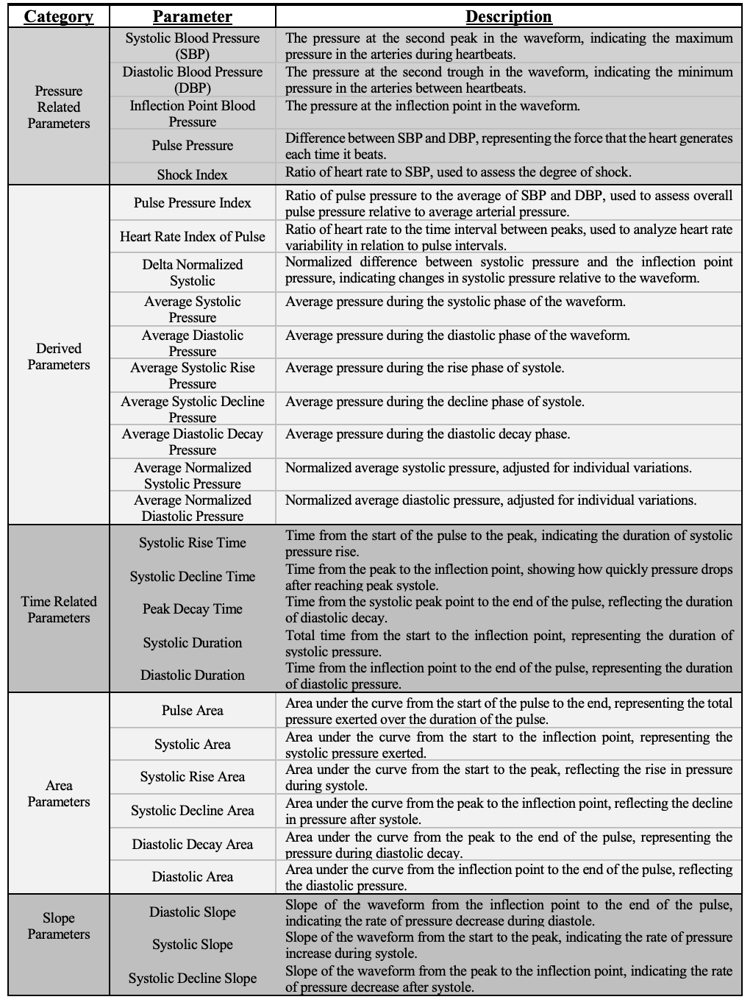

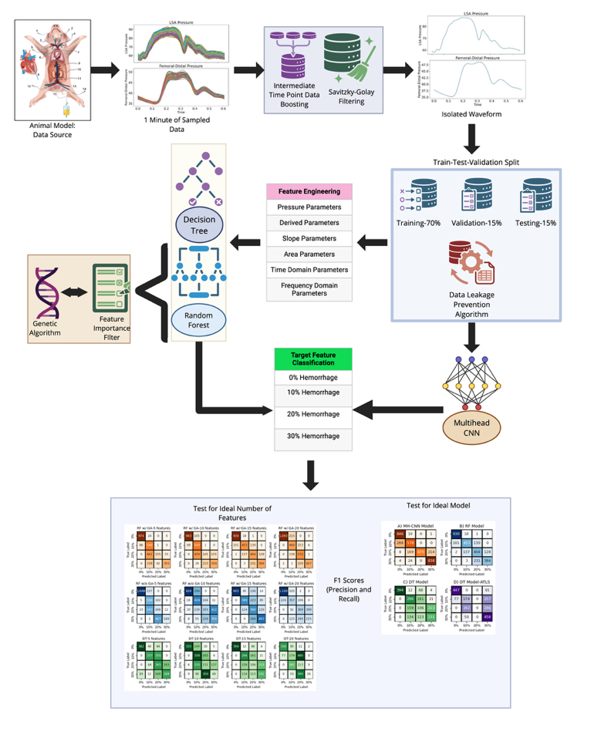
Figure 2. Visual representation of the arterial pressure waveform data processing and side-by-side model development comparison.

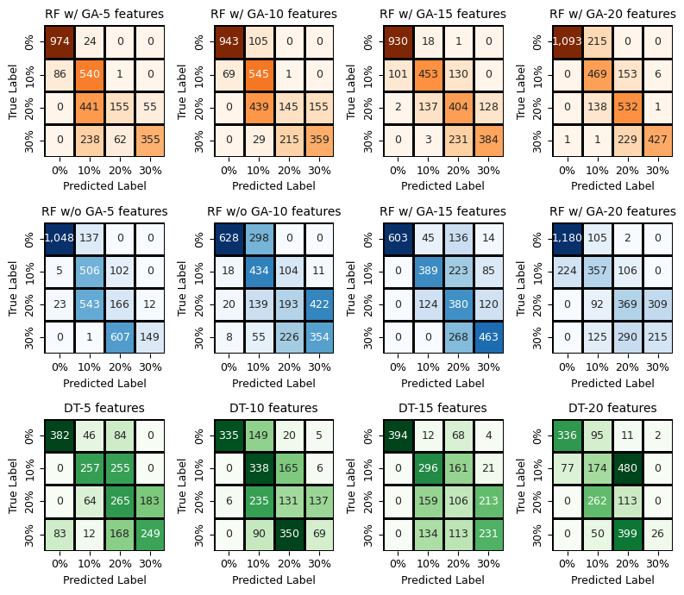
Figure 3. Testing feature importance across ML models. Models which had 15 features exhibited the F1 scores and high accuracies. RF models with GA also outperformed RF models without GA, and both models outperformed DT. Confusion matrices for the Random Forest model (top row – w/GA, middle row- w/o GA) with 5, 10, 15 and 20 features are shown. The bottom row illustrates the matrices for the Decision tree model with 5, 10, 15 and 20 features. Introduction of GA positively improves model variance, improving model performance in GA w/GA. Additionally, we see a consistent improvement with 15 features in both the RF and DT models. The top 20 features across models were as follows: (A) Derived Features: Pulse Pressure, Average Pressure, Minimum Pressure, Max Pressure, MAP, Augmentation Pressure (B) Time-Domain Features: Heart Rate, Heart Rate Interval, Peak-to-Peak Interval, Inflection Time (C) Frequency-Domain Features: Fast Fourier Transform Frequency and Power Spectal Density.

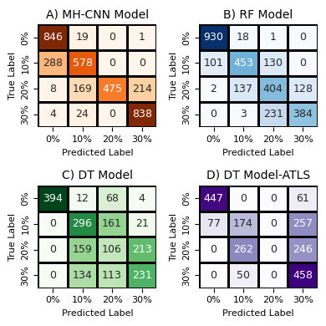
Figure 4. Confusion matrices from each AI model for hemorrhage classification. A) 1D MH-CNN model (79% accuracy) B) Random Forest model (w/GA) (74% accuracy-15 features) C) Decision Tree (54% accuracy-15 features) D) Decision Tree with only ATLS features (54% accuracy-3 features).

Table 3. F1 scores with respect to each machine learning model and number of features.
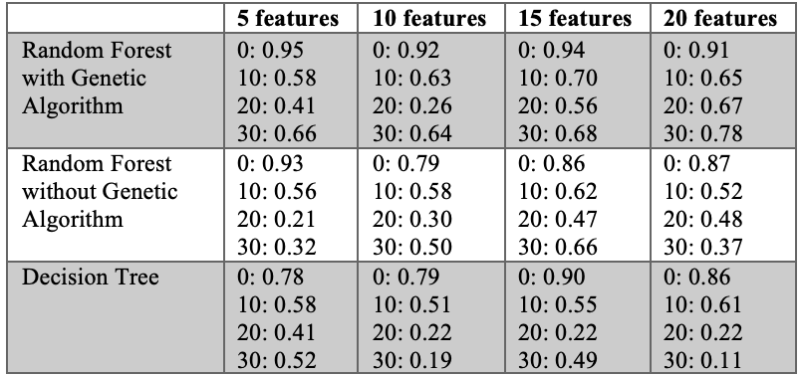

Table 4. Full classification metrics table across four models.
Model | Metric | 0% | 10% | 20% | 30% | Avg
Multi-Head CNN | Precision | 0.74 | 0.73 | 1.00 | 0.80 | 0.82
 | Recall | 0.98 | 0.67 | 0.55 | 0.97 | 0.79
 | F1 Score | 0.84 | 0.70 | 0.71 | 0.87 | 0.78
Random Forest (GA) | Precision | 0.90 | 0.74 | 0.53 | 0.75 | 0.73
 | Recall | 0.98 | 0.66 | 0.60 | 0.62 | 0.72
 | F1 Score | 0.94 | 0.70 | 0.56 | 0.68 | 0.72
Decision Tree (15 features) | Precision | 1.00 | 0.49 | 0.24 | 0.49 | 0.56
 | Recall | 0.82 | 0.62 | 0.22 | 0.48 | 0.54
 | F1 Score | 0.90 | 0.55 | 0.23 | 0.49 | 0.54
Decision Tree (ATLS) | Precision | 0.85 | 0.36 | 0.00 | 0.45 | 0.42
 | Recall | 0.88 | 0.34 | 0.00 | 0.90 | 0.53
 | F1 Score | 0.87 | 0.35 | 0.00 | 0.60 | 0.45

Table 5. Feature importance across models.
